Rabih Mroue: I, The Undersigned – The People are Demanding

A select bibliography of materials available in the Stuart Hall Library

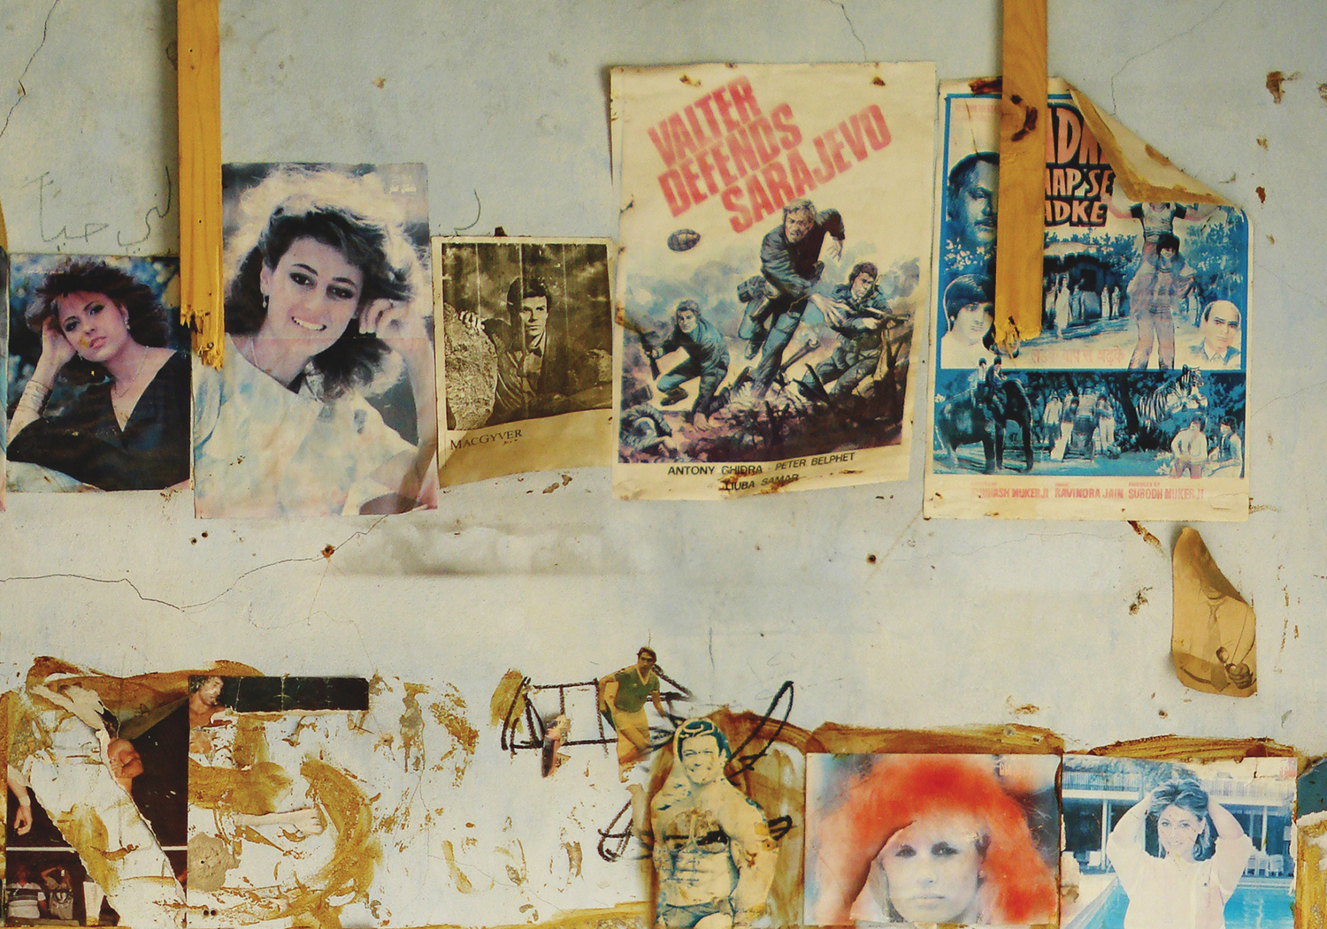

Exhibition catalogues featuring Rabih Mroue

ITEM LIBRARY
SHELF NO.

Berlin documentary forum 1 431.131 BER
Edited by Hela Peleg and Bert Rebhandi
2010
Published on the occasion of the Berlin Documentary Film Forum 1, 2-6 June 2010, at the Haus der Kulturen der Welt, Berlin, Germany. Participants include Emily Apter, Ariella Azoulay, Ecke Bonk, Stella Bruzzi, Francois Bucher, Eduardo Cadava, Tony Cokes, Chris Marker, Catherine David, Okwui Enwezor, Omer Fast, Rene Gabri, Ayreen Anastas, Philip Gourevitch, Brian Holmes, Thomas Keenan, Bettina Knaup, Joachim Koester, Antjie Krog, Xavier Le Roy, Angela Melitopoulos, Marie-Jose Mondzain, Joao Moreira Salles, Edgar Morin, Michael Mrakitsch, Rabih Mroue, Issam Nassar, Marcel Ophuls, Rick Prelinger, Uruphong Raksasad, Jacques Ranciere, Alain Resnais, Adrian Rifkin, Ben Russell, Walid Sadek, Lee Anne Schmitt, Florian Schneider, Stefanie Schulte Strathaus, W. G. Sebald, Eileen Simpson, Ben White, Eyal Sivan, Eduardo Thomas, Frederick Wiseman, Dolores Zinny, Juan Maidagan.

Hamra Street project 569.3 HAM
2000
The project 'Hamra Street' was initiated by the Lebanese Association for Plastic Arts "Ashkal Alwan" inviting a group of artists and writers enquiring about the image of Lebanon, resisting the recent wars, on the example of this street 'Hamra Street', which has always been a cause of fascination. Contributors include: Akram Zaatari; Feyrouz Serhal; Bilal Merhi Khbeiz; Nesrine Khodr; Rabih Mroue; Ghassan Salhab; Jalal Toufic; Mahmoud Hojeij; Lamia Joreige; Rita Awn; Tony Michel Chakar; Nadine Rachid Laure Touma; Salah Saouli and Walid Boutros Sadek.

Home works: a forum on cultural practices in the 569.3 HOM
region Egypt, Iran, Iraq, Lebanon, Palestine and Syria
edited by Christine Tohme and Abu Rayyan
2003
Stimulating the exchange of cultural practices, Ashkal Alwan initiated a forum inviting artists, critics and practitioners from Egypt, Iran, Iraq, Lebanon, Palestine and Syria to a conference in 2002. Participants include: Jananne Al Ani; Abbas Baydoun; Catherine David; Joana Hadjithomas and Khalil Joreige; Samia Mehrez; Issam Nassar; Rasha Salti; Jalal Toufic; Akram Zaatari; Tirdad Zolghar; Hassan Khan; Lina Saneh and Rabih Mroue; Nadine R. L. Touma; Bita Fayyazi; Khalil Rabah; Randa Shaath; Shadi Abdel Salam; Nizar Hassan; Ibrahim Mokhtari; Ghassan Salhab; Mohammed Soueid and Elia Suleiman.

Insan Neyle Yasar? = What keeps mankind alive? 560.118 BIE
11. Uluslararasi Istanbul Bienali : metinler =
11th International Istanbul Biennial : the texts
2009
Published on the occasion of the 11th Istanbul Biennial September 12 - November 8 2009. Includes work, texts and citations by Jumana Emil Abboud, Meltem Ahiska, Vyachslav Akunov, Mounira Al Solh, Nevin Aladag, Huseyin Bahiri Alptekin, Doa Aly, Karen Andreassian, Yuksel Arslan, Alain Badiou, Zanny Begg, Lidia Blinova, Anna Boghiguia, Bertholt Brecht, KP Brehmer, Boris Buden, Ayse Bugra, Bureau d'etudes, Keti Chukhov, Cengiz Cekil, Eda Cufer, Danica Dakic, Lado Darakhevelidze, decolonizing.ps [Sani Hilal, Alessandro Petti, Eyal Wiezman], Elin Diamond, Mladen Dolar, Bob Dylan, Natalya Dyu, Rena Effendi, Isil Egrikavuk, Omnia El Shakry, Etcetera, Sureyyya Evren, Morad Farhadpour, Han-Peter Feldmann, Shahab Fotouhi, Inci Furni, Luis Ignacio Garcia, Igor Grubic, Nilbar Gures, Margaret Harrison, Sharon Hayes, Brian Holmes & Claire Pentecost, Vlatka Horvat, Wafa Hourani, Hamlet Hovsepian, Sanja Ivekovic, Fredric Jameson, Dongwan Jo & Haejun Jo, Jesse Jones, Alimjan Jorobaev, Michel Journiac, Dejan Krsic, KewieKulik [presented by Zofia Kulik 'in sunumu ile], Sinisa Labrovic, Catisma Belirtileri: Lubnan Ic Savasi'ndan Siyasi Afisler, Bir Zeina Maasri projesi / Signs of Conflict: Political Posters of Lebanon's Civil War [a project by Zeina Maasri], David Maljovic, Marwan, Minqi Li, Avi Mograbi, Rabih Mroue, Aydan Murtezaoglu & Bulent Sangar, Museum of American Art, Marina Naprushkina, Deimantas Narkevicius, Ioana Nemes, Wendelien van Oldenborgh, Mohammed Ossama, Erkan Ozgen, Trevor Paglen, Nam June Paik, marko Peljhan, Harold Pinter, Darinka Pop-Mitic, Lisi Raskin, Maria Ruido, Larissa Sansour, Hrair Sarkissian, Ruti Sela & Maayan Amir, Canan Senol, Societe Realiste, Mladen Stilinovic, Tamas St.Auby, Darko Suvin, Oleg Suran, Jinoos Tahizadeh, Oraib Toukan, Vangelis Vlahos, Simon Wachsmuth, WHW, Stephen Wright, Artur Zmijewski, Slavoj Zizek.

Insan Neyle Yasar? = What keeps mankind alive? 560.118 BIE
11. Uluslararasi Istanbul Bienali : rehber =
11th International Istanbul Biennial : the guide
2009
Exhibition guide published on the occasion of the 11th Istanbul Biennial September 12 - November 8 2009. Includes work by Jumana Emil Abboud, Meltem Ahiska, Vyachslav Akunov, Mounira Al Solh, Nevin Aladag, Huseyin Bahiri Alptekin, Doa Aly, Karen Andreassian, Yuksel Arslan, Alain Badiou, Zanny Begg, Lidia Blinova, Anna Boghiguia, Bertholt Brecht, KP Brehmer, Boris Buden, Ayse Bugra, Bureau d'etudes, Keti Chukhov, Cengiz Cekil, Eda Cufer, Danica Dakic, Lado Darakhevelidze, decolonizing.ps [Sani Hilal, Alessandro Petti, Eyal Wiezman], Elin Diamond, Mladen Dolar, Bob Dylan, Natalya Dyu, Rena Effendi, Isil Egrikavuk, Omnia El Shakry, Etcetera, Sureyyya Evren, Morad Farhadpour, Hans-Peter Feldmann, Shahab Fotouhi, Inci Furni, Luis Ignacio Garcia, Igor Grubic, Nilbar Gures, Margaret Harrison, Sharon Hayes, Brian Holmes & Claire Pentecost, Vlatka Horvat, Wafa Hourani, Hamlet Hovsepian, Sanja Ivekovic, Fredric Jameson, Dongwan Jo & Haejun Jo, Jesse Jones, Alimjan Jorobaev, Michel Journiac, Dejan Krsic, KewieKulik [presented by Zofia Kulik 'in sunumu ile], Sinisa Labrovic, Catisma Belirtileri: Lubnan Ic Savasi'ndan Siyasi Afisler, Bir Zeina Maasri projesi / Signs of Conflict: Political Posters of Lebanon's Civil War [a project by Zeina Maasri], David Maljovic, Marwan, Minqi Li, Avi Mograbi, Rabih Mroue, Aydan Murtezaoglu & Bulent Sangar, Museum of American Art, Marina Naprushkina, Deimantas Narkevicius, Ioana Nemes, Wendelien van Oldenborgh, Mohammed Ossama, Erkan Ozgen, Trevor Paglen, Nam June Paik, marko Peljhan, Harold Pinter, Darinka Pop-Mitic, Lisi Raskin, Maria Ruido, Larissa Sansour, Hrair Sarkissian, Ruti Sela & Maayan Amir, Canan Senol, Societe Realiste, Mladen Stilinovic, Tamas St.Auby, Darko Suvin, Oleg Suran, Jinoos Tahizadeh, Oraib Toukan, Vangelis Vlahos, Simon Wachsmuth, WHW, Stephen Wright, Artur Zmijewski.

Les Inquiets. Cinq artistes sous la pression de la guerre 443.6 LES
= the anxious : five artists under the pressure of war
Curated by Joanna Mytkowska and Anna Hiddleston
Published to coincide with the exhibition The Anxious. Yael Bartana,
Omer Fast, Rabih Mroue, Ahlam Shibli, Akram Zaatari. Five Artists Under the Pressure of War, in the Espace 315, at the Centre Pompidou, Musee national d'art moderne, Paris, 13 February-19 May 2008.

Medium religion : faith. geopolitics. art 430.131 MED
Edited by Boris Groys and Peter Weibel
2009
Published on the occasion of the exhibition Medium Religion, curated by Boris Groys and Peter Weibel. Artists include Abdel Abdessemed, Oreet Ashery, Maja Bajevic, Peter Bogers, Christoph Buchel, Paul Chan, Susana Pilar, Wim Delvoye, Dias and Riedweg, Valie Export, Ingrid and Oswald Wiener, Omer Fast, Barbad Golshiri, Boris Groys, Huang Yong Ping, IRWIN, Romuald Karmakar, Vitaly Komar, Beryl Korot and Steve Reich, Korpys/Loffler, Alexander Kosolapov, Florian Meyer, Rabih Mroue, Dorcas Muller, Sang-Kyoon Noh, Nira Pereg, robotlab, Osvaldo Romberg, Anri Sala, Gunter Saree, Konrad Balder Schauffelen, Christoph Schlingensief, Michael Schuster, Wael Shawky, Jalal Toufic, Vadim Zakharov, Hermes Zygott. Writers include Hent de Vries, Kajri Jain, Vitaly Komar and Alexander Melamid, Dorna Safaian, Natalia Schmidt, Joshua Simon, Peter Sloterdijk, Henry Zemel, and Slavoj Zizek.

Out of Beirut 569.3 OUT
2006
Published on the occasion of the exhibition at Modern Art Oxford May - July 2006. Beirut unbound by Suzanne Cotter; Smuggling practices into the image of Beirut by Simon Harvey; Territories of difference: excerpts from an e-mail exchange between Tony Chakar, Bilal Khbeiz and Walid Sadek by Stephen Wright; Contemporary art practices in post-war Lebanon: an introduction by Kaelen Wilson-Goldie; Onto the streets: the Heartland Collective's interventionist perspective by Kaelen Wilson-Goldie. Artists include: Ziad Abillama; Tony Chakar; Ali Cherri; Joana Hadjithomas & Khalil Joreige; Gilbert Hage; Heartland; Lamia Joreige; Bernard Khoury; Rabih Mroué; Walid Raad; Walid Sadek; Jalal Toufic; Paola Yacoub & Michel Lasserre; Akram Zaatari.

Tamáss: contemporary Arab representations: 53 TAM
Beirut/Lebanon
2002
Published in the framework of the Contemporary Arab Representations, Beirut/Lebanon project that took place at the Fundació Antoni Tàpies, Barcelona, 3 May - 14 July 2002. Project directed by Catherine David and produced by the Fundació Antoni Tàpies in association with Witte de With, Rotterdam. Contributors: Catherine David; Walid Sadek; Jalal Toufic; Saree Makdisi; Tony Chakar; Bilal Khbeiz; Elias Khoury; Rabih Mroue; Marwan Rechmaoui; Paola Yacoub Michel Lasserre.

Articles

11th International Istanbul Biennial
Amna Malik
In: Third Text vol.24 no.4 (July 2010)
Review of the 11th Istanbul Biennial. The Biennial titled 'What Keeps Mankind Alive' was curated by the feminist collective What How and For Whom. Featuring artists Jumana Emil Abboud, Larissa Sansour, Ruti Sela, Maayan Amir, Avi Mograbi, Mounira Al Solh, Rabih Mroue, Zeina Masri, Mohammed Ossama, Artur Zmijewski, Igor Grubic, Fredric Jameson.

Parachute 108 : Beyrouth Beirut
October 2002
Special issue of Parachute: revue d'art contemporain, focusing on Beirut, Lebanon. Contributors include: Stephen Wright; Walid Sadek; Rabih Mroue; Tony Chakar; Sarah Rogers; Mahmoud Hojeij; Mohamad Soueid; Akram Zaatari; Paola Yacoub; Michel Lasserre; Amale Andraos; Bilal Khbeiz; Hashim Sarkis; Dina Al-Kassim; Michael Allan; Richard Noble; Gilbert Boyer. Examines the work of artists both residing in Beirut and a part of its diaspora, including: Walid Sadek; Akram Zaatari; Mohmed Soueid; Mahmoud Hojeij; Michel Lasserre and Paola Yacoub; Walid Ra'ad; Bilal Khbeiz; Rabih Mroue; Tony Chakar; Jayce Salloum; Mona Hatoum.

Review : looking for a missing employee
Pierre Abi Saab
In: Pages no. 2 (May 2004)
Second issue of Pages published with the support of the KunstenFESTIVALdesArts in Brussels, presenting the second part of News from Tehran initiated by the artists Nasrin Tabatabai and Babak Afrassiabi. Includes Arash Mozafari 'A city built by its inhabitants'; Pierre Abi Saab review of Rabih Mroue 'Looking for a missing employee'; Pierre Abi Saab 'Review: 'Looking for a missing employee' performance; Arta Group in collaboration with Pages magazine 'Nothing will ever happen here, nothing had ever happened'; Yto Barrada 'The strait or a life full of holes (1998-2004)'; Vesta Nele Zareh 'The case of two American embassies'; Nasrin Tabatabai and Babak Afrassiabi ' Interview with Steve McQuen'; Maani Petgar 'An eclipse, which dropped from the sky'; Gelayol Mosaed and Mohammad Hassan Malekpour 'Diagram and Rhizome'.
Text in English and Farsi.

Sharjah Biennial 9: Provisions for the future
November Paynter
In: Art Asia Pacific no. 94 (July-August 2009)
The 2009 Sharjah Biennial featuring over 80 participating artists does not directly address a specific theme. This review discusses the sense of detachment in relation to specific works. Featuring artists Mariam Ghani, Erin Ellen Kelly, Lara Favaretto, Karin Sander, Ayse Erkmen, Rabih Mroue, Maha maamoun, Hala Elkoussy, Sheela Gowda, Lamia Joreige, Andrei Tarkovsy.

Contextual Resources

AfterShock. Conflict, violence, and resolution in 410 AFT
contemporary art
Sainsbury Centre for Visual Arts
2007
Aftershock features works by artists that incorporate concepts of conflict, violence, memory, and identity.

Art of the Middle East. Modern and contemporary art ESS ART
of the Arab world and Iran
By Saeb Eigner
Merrell
2010
A survey of modern and contemporary art of the Arab world and Iran from the mid-1950s to the present day.

Art and social change. A critical reader ESS ART
Edited by Will Bradley & Charles Esche
Tate Publishing
2007
This reader gathers together an international selection of artists' proposals, manifestos, theoretical texts and public declarations that focus on the question of political engagement and the possibility of social change. The approaches represented are many and diverse, from Gustave Courbet's involvement in the Paris Commune and the socialist art theory of William Morris to the hybrid activist practice associated with the twentry-first century 'movement of movements'; from the political commitments of the Modernist avant gardes to the rejections of Modernism in favour of protest, critique, utopian social experiment or revolutionary propaganda.Featuring six especially comissioned essays by Geeta Kapur, Lucy Lippard, John Milner, Gerald Raunig, Marina Vishmidt, Tirdad Zolghadr. Featuring texts by and about Gustave Courbet, William Morris, Walter Crane, John Reed, Richard Huelsenbeck, Komfut, Alexander Rodchenko, Vavara Stepanova, William Pickens, Theo van Doesburg, Mieczyslaw, The John Reed Clubs, Oswald de Andrade, Kurt Tucholsky, KOSTUFRA, Felicia Browne, Laszlo Moholy-Nagy,Georges Maciunas, Fluxus Manifesto, The Situationist International, Black Mask, Sture Johannesson, Psychadelic Manifesto, The Diggers, Emory Douglas, Hans Haacke, The Guerrilla Art Action Group, Cildo Meireles, Radical Software, The Kabouters, VALIE EXPORT, Brigadas Ramona Parra, Solvognen, Augusto Boal, Zoran Popovic, Adrian Piper, Peter Kennard, Raqs Media Collective.

Geographies of resistance ESS GEO
Edited by Steve Pile and Michael Keith
Routledge
1997
Introduces new understandings of resistance, questioning received notions and presenting radical reinterpretations of the relationship between political identities, political spaces and radical politics. Drawing on a wide range of critical therories, such as postcolonialism and queer theory, the authors define new political spaces and understand struggles to turn sites of oppression and discrimination into spaces of resistance. Some of the chapters include: Opposition, political identities and spaces of resistance; State violence, local resistance and the national question in Nigeria; Theory and practice in Nepal's Revolution of 1990; Ground for struggle and the politics of place; Sex, money and the uneasy politics of third space; The curious case of ACT UP Vancouver; Gay judges and moral panic in contemporary Scotland. Contributors include: Michael Brown; Michael Dear; Shlomo Hasson; Jane M. Jacobs; Michael Keith; Lawrence Knopp; Lisa Law; Donald S. Moore; Steve Pile; Gillian Rose; Paul Routledge; David Slater; Nigel Thrift; Michael Watts.

Middle Eastern Belongings ESS KIN
Edited by Diane E. King
Routledge
2010
This book features chapters that examine the various ways of belonging to the Middle East. Belonging can mean fitting in, feeling at home, feeling a part; this kind of belonging is profoundly social .

